February 7, 2023
Good Morning,
I am attaching the much simplified version of the Marshall County monthly update. Try as I may, for some reason I could not copy and paste the state map reflecting the current transmission levels by county from the kycovid19 webpage. Use of technology has never been my strength. I did however include the link. Or anyone can go to www.kycovid19.ky.gov , view the maps, and retrieve as much information as possible.
Marshall County remains in the medium (yellow) range for COVID19 transmission. Much of the state is at a low level (green) and the number of positives in Marshall decreased to 82 for February; this is a steady decrease since November.
We are headed in the right direction. Thank you all for your efforts to keep our community safe!
Billy Pitts, MHA, MHR
Public Health Director
Marshall County Health Department
Office 270-252-2700
Mobile 270-970-1957

Monthly Update
For February 2023

https://govstatus.egov.com/kycovid19

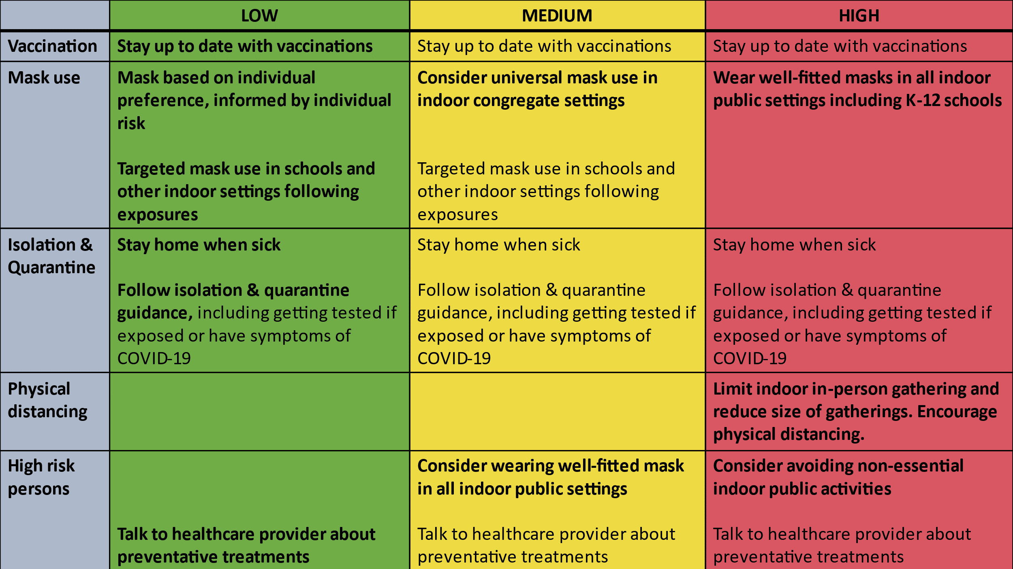

Here is the data for Marshall County as of February 28, 2023.
Total COVID Cases 10,544 (Increase of 82)
Hospitalizations for the month 5 (No change)
Total COVID related deaths 129 (Increase of 2)

 | Feb 2023 | Jan 2023 | Dec 2022 | Nov 2022 | Oct 2022
Cases for the month | 82 | 121 | 234 | 244 | 101
COVID related Deaths | 2 | 2 | 0 | 0 | 0

